Declarative pipeline using feature 1.1 branch
First install these plugins
Git
Pipeline
Pipeline: Stage View
SonarQube Scanner
Nexus Artifact Uploader
Deploy to container
Slack Notification
Maven Integration
We already have most of the plugins lets install which we do not have
Go to manage Jenkins pluginsavailable plugins
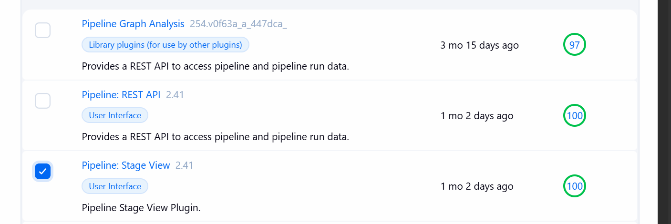
Now create a pipeline job
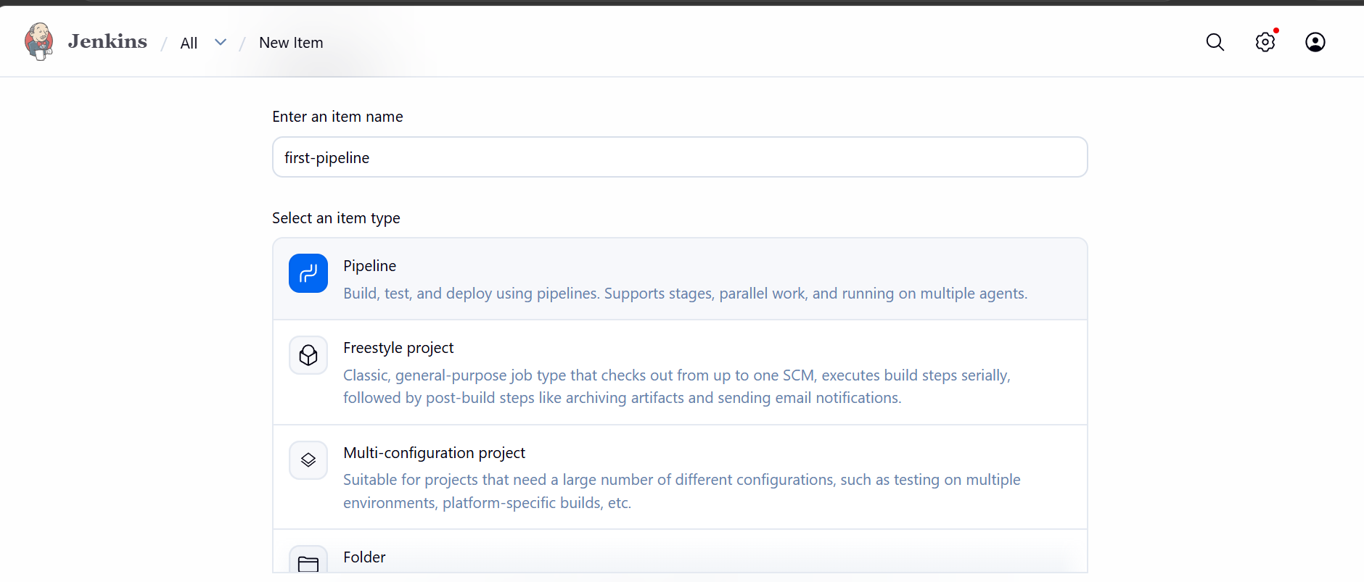
First lets work with git clone
Trigger the build now
Build is successful
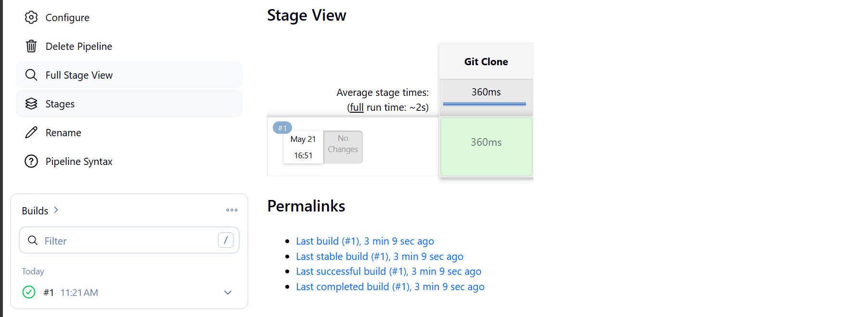
Now lets add sonarqube analysis to it
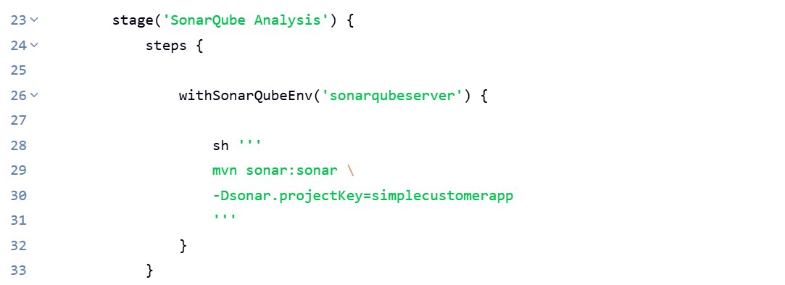
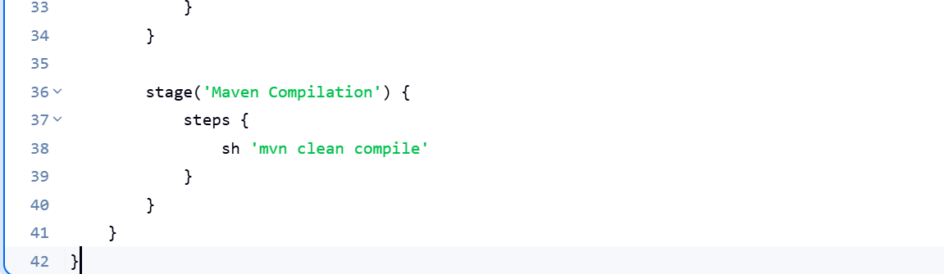
Doing sonarqube analysis and building the package
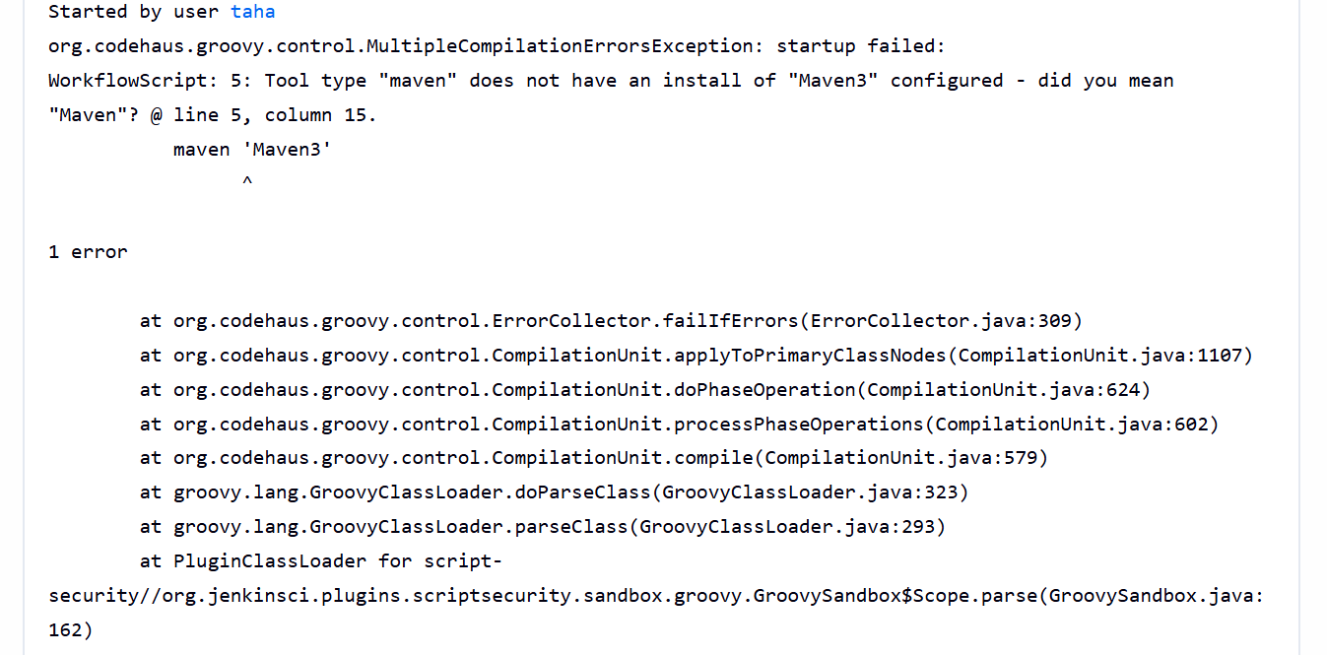 error came while running the pipeline
Jenkins does not understand maven3
Changed maven3 to maven
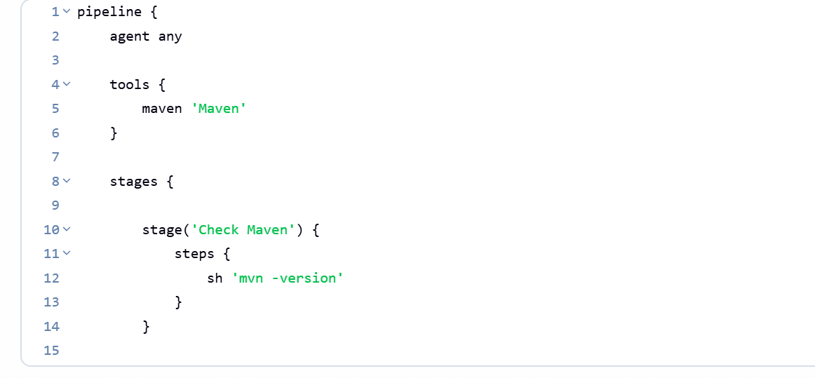
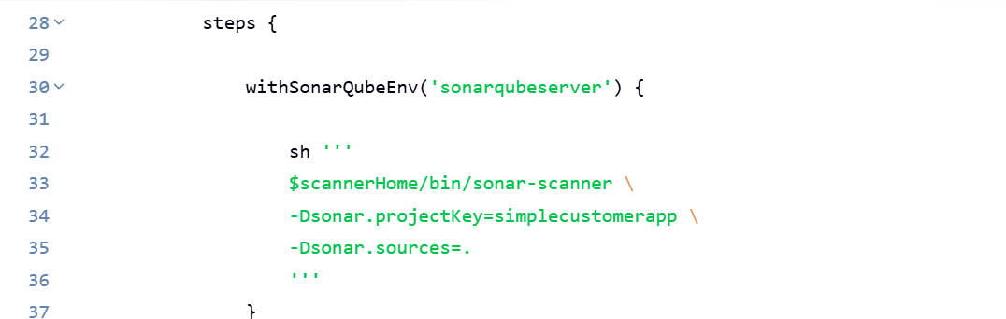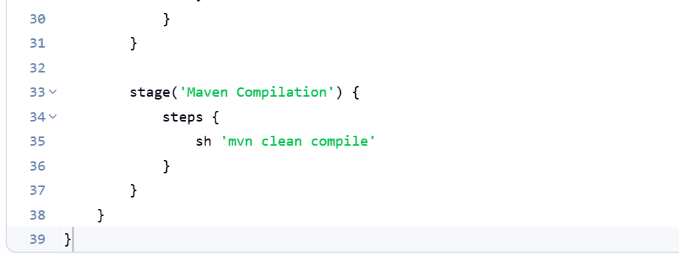
Now it ran succesfully
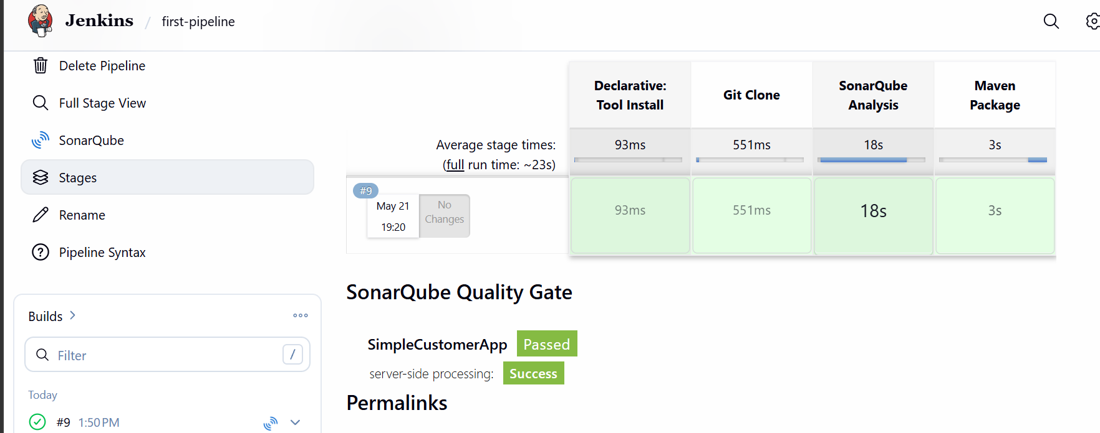
Now lets upload the artifact to nexus repo
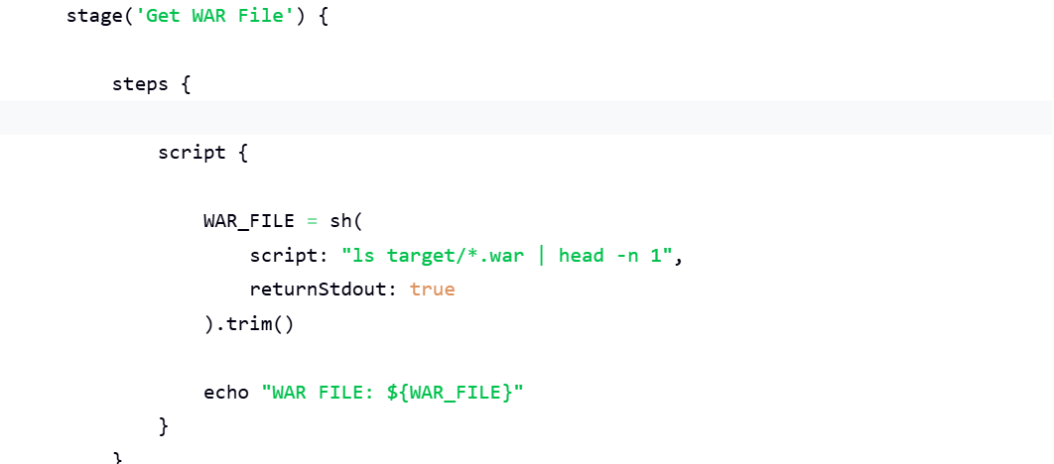
Script to get war file and push to nexus repo
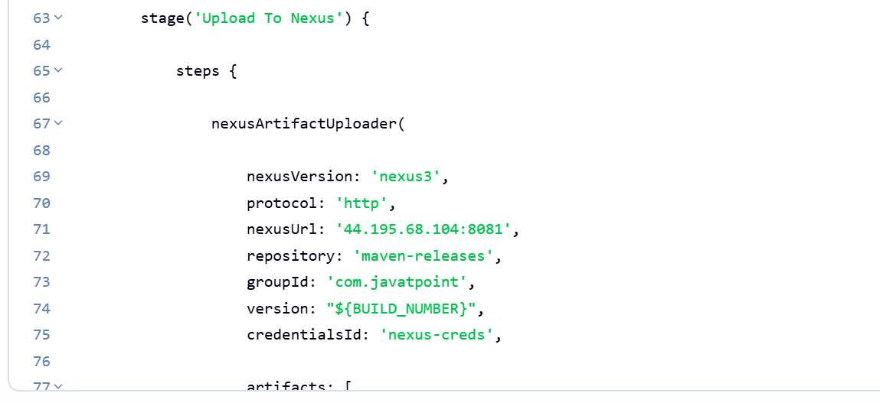
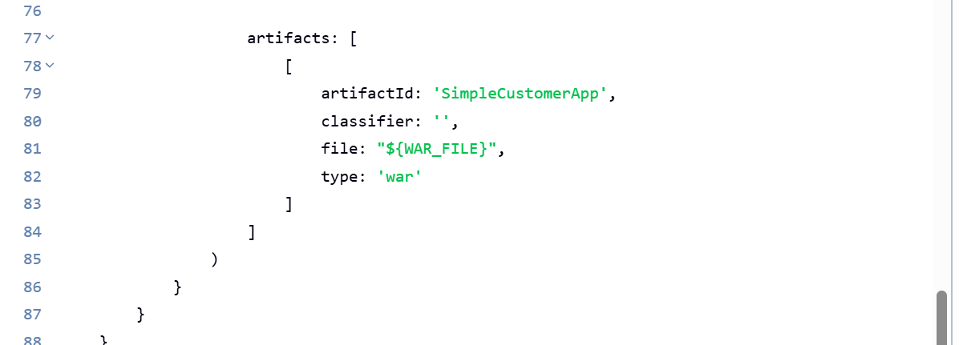

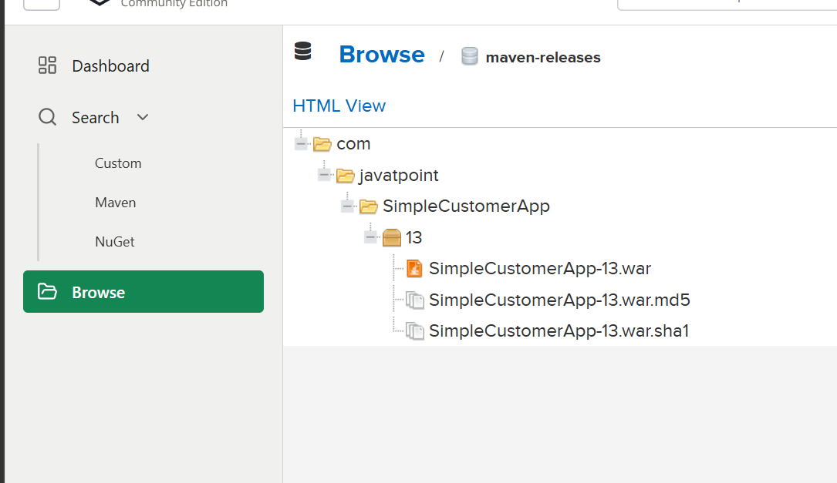

Now deploy to tomcat
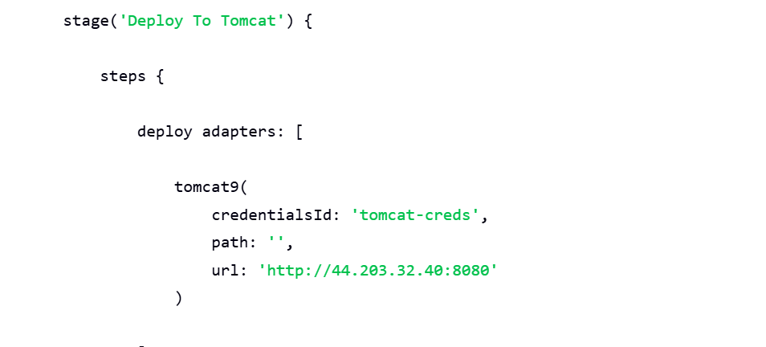
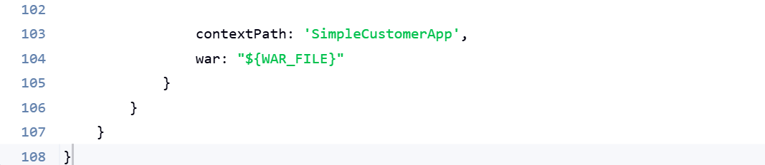
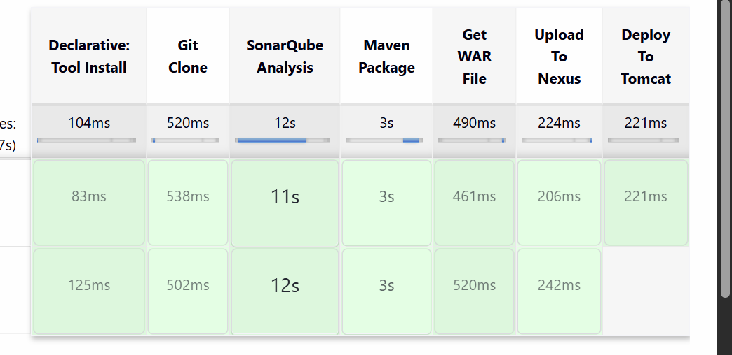

Deployment is successful

